**For Immediate Release:** June 10, 2021

**National Building Museum Announces Its**

**2021 Summer Block Party Lineup**

In the Great Hall, three complex wood structures; on the West Lawn,

free weekly movies and an interactive design on the grass.

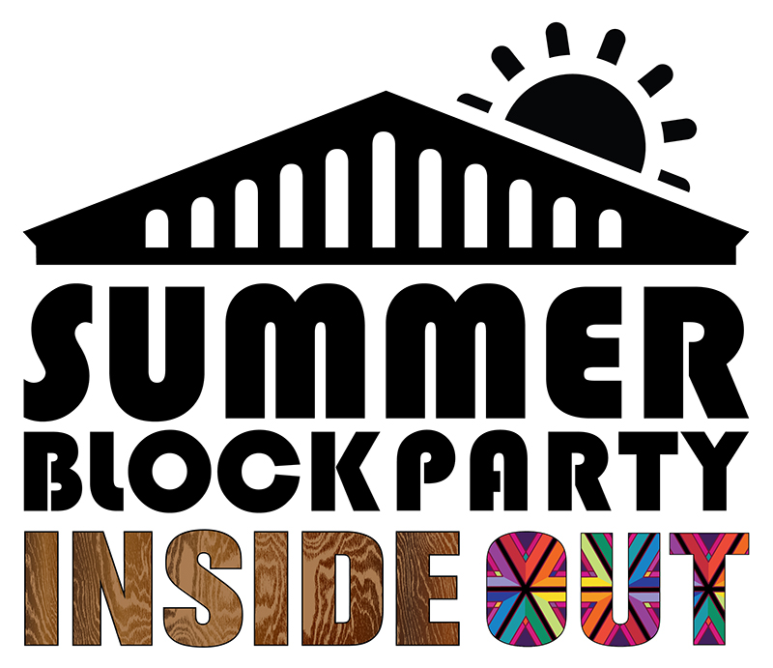

WASHINGTON, D.C.—Today the National Building Museum announced its [**2021 Summer Block Party, *Inside Out***](https://www.nbm.org/exhibition/inside-out/). Where previous years have showcased massive, immersive, crowd-inducing installations in the Great Hall, this year’s iteration features a handful of smaller projects and public programs both within the Museum and on the West Lawn that are better suited to this early post-pandemic era of smaller gatherings and social distancing, including a wooden maze filled with books, a hand-built cathedral truss, public programs, and, thanks to a partnership with the DowntownDC Business Improvement District (BID), interactive lawn art and outdoor movies.

“It is a treat for the Museum to be able to offer D.C. residents and visitors a variety of experiences this summer that fulfill our mission in many ways, from amazing architecture and engineering installations to engaging educational programs to partnerships with local organizations, artists, and designers,” said Aileen Fuchs, President and Executive Director of the Museum.

**INSIDE THE MUSEUM**

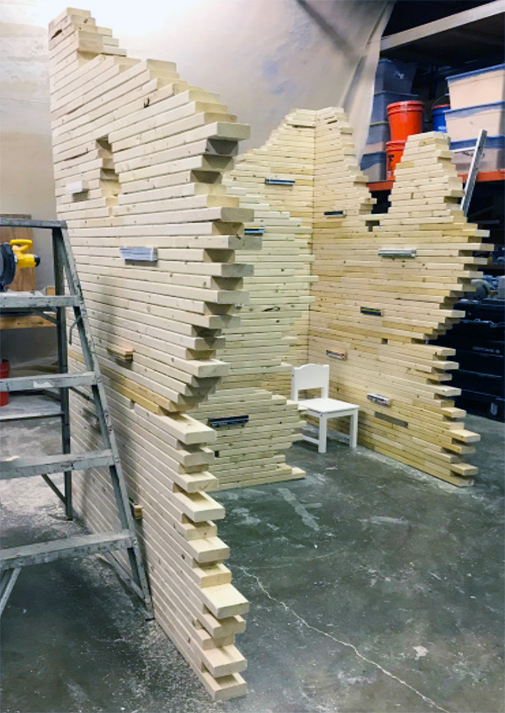**Maze of Knowledge**

Conceived by D.C.-area sculptor Foon Sham, this 26-foot-square, 8-foot-high labyrinth will engage visitors of all ages. With vertical walls and horizontal broken brick-line contours made of wooden blocks sourced from building materials, the installation will resemble a dilapidated structure. The *Maze of Knowledge* symbolizing how humans acquire information and understanding from the ruins of the past. Dozens of books, representing this acquired knowledge, will be embedded within the layers of wood throughout the maze, offering visitors an incentive to traverse its many paths and discover the variety of works it contains. The maze, which will be in the west court of the Great Hall, will open on June 26 and remain through September 6.

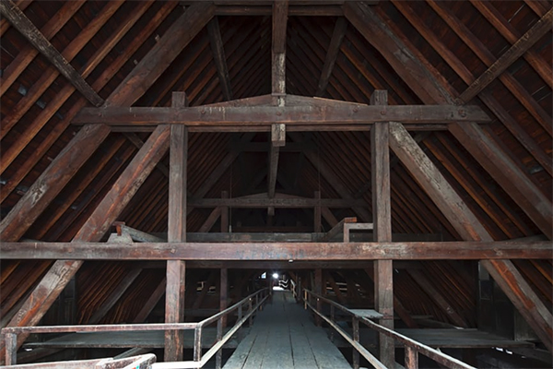**Notre Dame Truss Project**

Inspired by the terrible April 2019 fire that nearly destroyed the Notre-Dame de Paris cathedral, Massachusetts-based Handshouse Studio, which develops projects outside of the traditional design and construction classroom that energize history through the reconstruction of large historical objects, has partnered with multiple organizations, including the National Park Service and the School of Architecture and Planning at D.C.’s Catholic University, to design, construct, and raise a traditional timber-frame truss built to the cathedral’s specifications. The structure will be erected in the southeast corner of the Great Hall in early August and will remain on-site through the end of summer. The long-term goal for the project is to donate the truss to the cathedral so that it can be used in the rebuilding process.

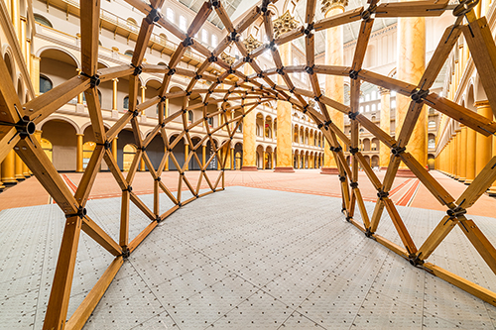**Lo-Fab Pavilion**

How can complex structures be built in areas where skilled labor is in short supply? How can designers use local materials to construct large structures with small components? The Lo-Fab Pavilion offered MASS Design Group the chance to explore these questions with the Virginia Tech School of Architecture + Design’s Center for Design Research. Created for the 2015 Design Boston Biennial, the Lo-Fab Pavilion is an experimental grid-shell structure merging traditional craftsmanship and computationally driven manufacturing processes, featuring metal nodes created through robotic-fabrication techniques and hand-cut wooden struts joined to them manually to erect the structure. A section of the Lo-Fab Pavilion has been built as part of the exhibition [*Justice is Beauty: The Work of MASS Design Group*](https://www.nbm.org/exhibition/justice-is-beauty/). Located in the southwest corner of the Great Hall, it is available to experience through September 25, 2022.

**Programs**

Over the course of the summer, the Museum will be organizing online programs and “meet the artist” days for several participating *Inside Out* artists and designers. Subscribe to the Museum’s public programs newsletter at [go.nbm.org/newsletters](http://go.nbm.org/newsletters) for updates, or follow the Museum on social media.

**OUTSIDE THE MUSEUM**

Summer started early this year thanks to a Museum partnership with the DowntownDC BID to bring two experiences on the West Lawn for D.C. residents and visitors.

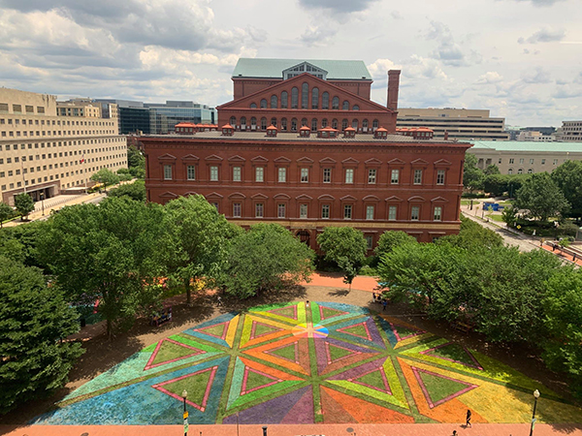**Interactive Lawn Art**

The BID commissioned D.C. muralist Lisa Marie Thalhammer to create a series of outdoor, lawn-based artworks around the neighborhood that would allow visitors to safely enjoy being together while social distancing. One of those designs, *Equilateral Network*, is now on the Museum’s lawn. A series of pink triangles and walking paths, comfortably spaced 6 feet apart, it was inspired by Pierre Charles L’Enfant’s use of sacred geometry in his 1791 city plan for Washington, D.C. The use of colors is also important, as rainbow spectrums and pink triangles are both historic symbols of identity and gay-rights activism, and the artwork was completed at the start of June, which is LGBTQ Pride Month. Created with environmentally safe materials, *Equilateral Network* will be touched up twice through the end of the June.

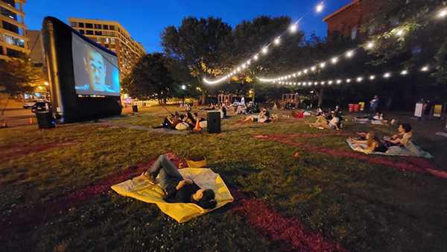**DowntownDC Summer Flicks**

The Museum is hosting the fourth annual *DowntownDC Summer Flicks–Can I Kick It?* outdoor free movie series, produced by the BID with local DJ collective Shaolin Jazz. This year’s theme is “The Future,” and weekly Tuesday night screenings that began on May 25 will travel through time and space across a range of science fiction movie favorites. Each film will be scored with an original music soundtrack of hip-hop, soul, and more mixed by weekly guest DJs. Movies begin at sunset, and attendees are encouraged to arrive at 7:30 pm for best seating. For those who arrive early: A series of swinging benches and tables are set up around the perimeter of the lawn. The series concludes on July 27, and the BID will offer two rain-cancelation dates, if necessary, on August 3 and 10. [Visit the BID website](https://www.downtowndc.org/event/downtowndc-summer-flicks-can-i-kick-it-2021/) for full details, including partnerships with neighborhood restaurants to offer attendees special discounts.

The Summer Block Party is generously supported by AARP, Presenting Sponsor. “AARP is honored to continue our support as the Presenting Sponsor of the National Building Museum’s Summer Block Party,” said Kevin Donnellan, Executive Vice President and Chief of Staff. “The range of opportunities presented by Inside Out offers something for visitors of all ages both in the Museum’s Great Hall and on the West Lawn this summer.”

CoStar Group is the Summer Block Party’s Gold Sponsor.

**PHOTOGRAPHS (FROM TOP)**(1) *Maze of Knowledge* mockup. Courtesy Foon Sham. (2) Trusses in the Notre-Dame de Paris cathedral, prior to the 2019 fire. Courtesy Notre-Dame de Paris/Maurice De Sully Association. (3) Lo-Fab Pavilion section. National Building Museum/Elman Studio. (4) *Equilateral Network* on the Museum’s West Lawn. Courtesy Lisa Marie Thalhammer. (5) Opening night of DowntownDC Flicks–Can I Kick It? on the West Lawn. Courtesy DowntownDC Business Improvement District.

**MEDIA CONTACT**Braulio Agnese, National Building Museum, [bagnese@nbm.org](mailto:bagnese@nbm.org)

**ABOUT THE NATIONAL BUILDING MUSEUM**

The National Building Museum inspires curiosity about the world we design and build. We believe that understanding the impact of architecture, engineering, landscape architecture, construction, planning, and design is important for everyone. Through exhibitions, educational programs, and special events, we welcome visitors of all ages to experience stories about the built world and its power to shape our lives, our communities, and our futures. Public inquiries: 202.272.2448, [info@nbm.org](mailto:info@nbm.org), or visit [www.nbm.org](https://www.nbm.org/). Connect with us on [Facebook](https://www.facebook.com/NationalBuildingMuseum), [Instagram](https://www.instagram.com/nationalbuildingmuseum/), and [Twitter](https://twitter.com/BuildingMuseum?ref_src=twsrc%5Egoogle%7Ctwcamp%5Eserp%7Ctwgr%5Eauthor).